Free Family Days Out Harrogate District
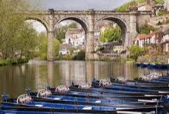
Picnic at Knaresborough River – Horse shoe field / Conyingham Hall parking.

Valley Gardens Harrogate Play park & Walk HG1 2SZ (Crazy Golf extra payment)
Bike ride Bilton to Ripley cycle way (Flat course)

Pine Woods Walk & Picnic near Valley Gardens
Birk Cragg, walk & scrambling in stream
Almscliffe Cragg, walk & climbing rocks

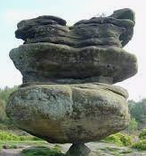Brimham Rocks HG3 4DW (Pay for parking)

7 Bridges walk Ripon

Reservoir walks: Swinsty, Fewston & Thrusscross – Car parking available
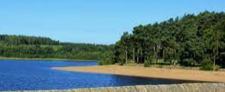

Further a field
West Yorkshire Sculpture Park (Pay for parking)
York Railway museum – Free entry (Use park & ride)
Otley Chevin – Walk & rocks LS21 3DG
Bolton Abbey (Pay for Parking £10)
Appletreewick river free parking

Pateley Bridge – Playgrounds and river walk
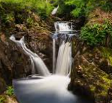 Ingleton Falls Walk – Walk around the top for free & see Thornton Force & Beezley Falls for free too.

Aysgarth Falls (DL8 3TH) Parking £4.50 all day £2.50 2hrs – Dog Friendly

Malham Cove
Golden Acre park 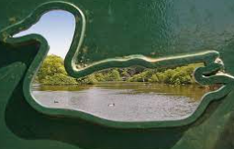
Roundhay Park - Leeds

Temple Newsam grounds
Closest Beach – Redcar, Saltburn, Filey Buckets & Spades 